CS4K8 Etoys
Unit 4 Champaign Schools

Project Title | Match Greek Gods
Author | Elizabeth Slifer
Project Image
Grade Level | Fourth
Curriculum Topic | Common core knowledge
Vocabulary | Poseidon, Apollo, Artemis, Orion, Athena
Project Description | Students will move speech bubbles or names to one another until the five are matched with correct speech bubble.
Scripts Images | 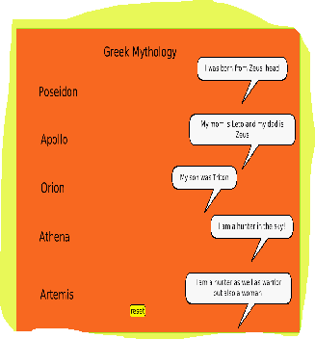
Extend | Learn more names of Greek Gods and create another playfield with different colors.
Extend
Advice
Hints
Links
Common Core

